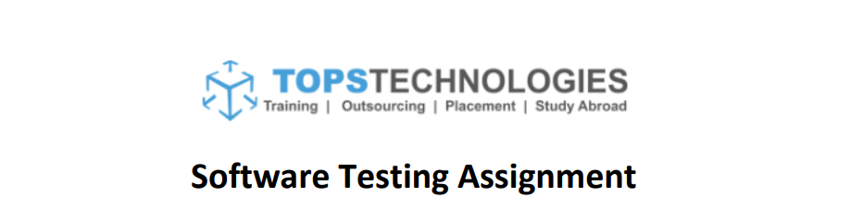

**Module -4(Defect Tracking)**

Q1. What is priority?

A1. The order in which a fault should be repaired is referred to as a priority. The higher the priority, the faster the problem should be fixed. Defect having the higher priority should be fixed first. Priority is of 3 types: Low, Medium, and High.

Q2. What is severity?

A2. Severity is defined as the extent to which a particular defect can create an impact on the software. Severity is related to the quality standard. Severity is of 5 types: Critical, Major, Moderate, Minor, and Cosmetic.

Q3. Bug categories are…

A3. Bug Categories are:

* Security
* Database
* Functionality (Critical/General)
* UI

Q4. Advantage of Bugzilla.

A4. The Advantages of Bugzilla are:

* it is an open-source widely used bug tracker;
* it is easy in usage and its user interface is understandable for people without technical knowledge;
* it easily integrates with test management instruments;
* it integrates with an e-mailing system;
* it automates documentation.

Q5. Difference between priority and severity

A5.

|  |  |
| --- | --- |
| **Severity** | **Priority** |
| Severity means how severe defect is affecting the functionality. | Priority means how fast defect has to be fixed. |
| Testing engineer decides the severity level of the defect. | Product manager decides the priorities of defects. |
| Severity is related to the quality standard. | Priority is related to scheduling to resolve the problem. |
| Its value does not change from time to time. | Its value changes from time to time. |
| Severity is of 5 types: Critical, Major, Moderate, Minor, and Cosmetic. | Priority is of 3 types: Low, Medium, and High. |